The
FPGA PACMAN
Engineering Plan
Boston University
Electrical and Computer Engineering
EC 551 : Advanced Digital Design
Prof. Taubin
Huaxin Dai (Leader)
Nael Musleh
Krishnan Nair
Level 0 of the Design:

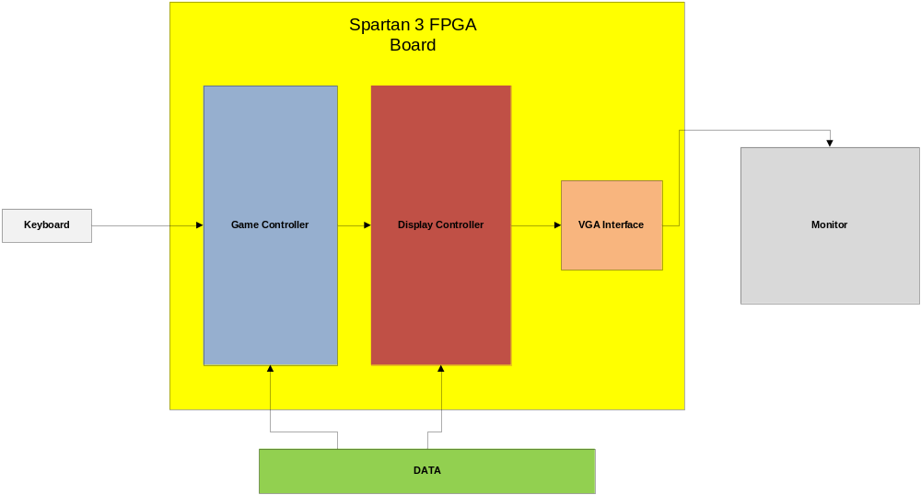

Keyboard Input(Huaxin’s part)
The keyboard input part’s main job is to get the input information from the keyboard and pass it to the game controller. This part contains the following two modules:

1. PS/2 interfacing module.
2. Input decoding module.

The PS/2 interfacing module’s main job is to decode the signal from the PS/2 port of the FPGA. PS/2 port is a serial interface, used for connecting devices like keyboard and mouse. Its pin map is shown below.
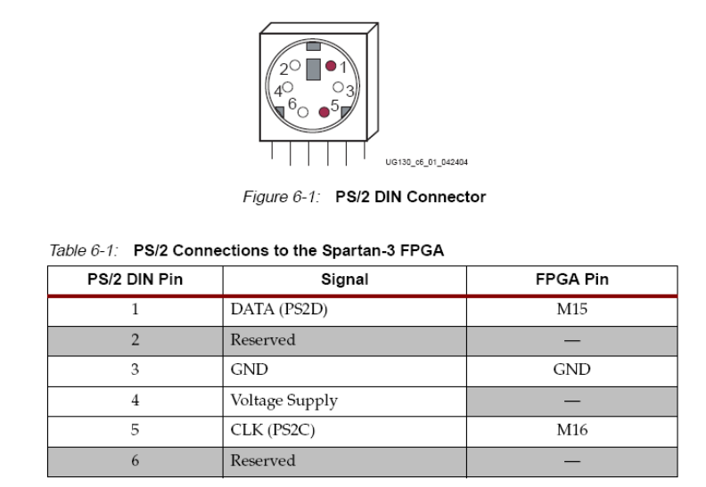
The communication between the keyboard and the FPGA board follows the protocol below:

1 start bit. This is always 0.
8 data bits, least significant bit first.
1 parity bit (odd parity).
1 stop bit. This is always 1.
And the waveform for that is:

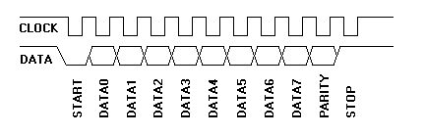
Here the clock frequency is between 10 kHz and 16.7 kHz. Since no instruction needs to be sent to keyboard, we don’t need to consider the situation. When the whole word is received, the interfacing module converts them and sends them to the decoding module.

Every key on the keyboard has been assigned a “codename” to represent them, and when it’s hit, the code is sent via PS/2 port to the FPGA board. Input decoding part’s job is to decode this and find out which key is hit. And pass this information to game controller part. Since we are using at most 6 keys(4 directions, a reset, and a pause), it’s more like a case statement with 6 cases needed to consider.

Tasks for this part:
1. Fetch the input signal from keyboard
2. Decode the signal and sense the key being pressed.
3. Send the decoded data to game controller module.

Schedule for completion of tasks:
Input signal fetch, 11/12-11/15
Signal decode and send, 11/15-11/16
Further testing, 11/16-11/18

Tools and resources to use:
A keyboard with PS/2 output, Xilinx ISE, Modelsim,Spartan3 Dev board.

Game controller(Huaxin and Krishnan’s Part)
The game controller is, after all, a big FSM. It decides what will be sent to display module, based on inputs of keyboard instruction and data available in RAMs and ROMs. It contains the following modules:
- main FSM. This is the module that collects all data and send them to display. Also this module controls the running of the game.
- pacman control. This module receives incoming instruction from keyboard and move coordinates of pacman.
- Ghost control. This module implements the move of ghosts.
- Collision detection. This is the core of the game controller. It detects all the collisions – pacman vs. ghost, pacman vs. wall, ghost vs. wall, etc. It’s crucial to keep the game running properly, that is to say, we don’t have pacman or ghost that go through the walls.
- Register files and data memories to keep data used for detection (will be done with Krishnan). This module is part of the supporting data files.
- Score register. A register to keep scores.
- Lives register. Whenever pacman runs into a ghost, it loses a life. When all lives are lost, game over.
- (Optional) energizer timer. This is activated when pacman eats an energizer, making pacman invincible and ghosts eatable like dots. But this situation cannot be held forever, so this timer tells when the status ends.
Tasks for this part include:
- Implement collision detect logic.
- Get pacman moving – that is, moving under keyboard control.
- Get ghost moving – that is, randomly moving.
- Give pacman a mouth – that is, implement “eating logic” so pacman can eat dots and, when energized, ghosts.
- Score keeping for eating dots, ghosts and clearing the boards. Also, lives keeping for ending the game.
- (Optional) make ghosts clever – that is, implement some tracking algorithm for ghosts to track pacman.
- (Optional) Energize pacman so it can eat ghosts.

Schedule for completion of tasks:
- main FSM: 11/12 – 11/24
- collision detect logic: 11/12 – 11/16
- pacman moving logic: 11/15 – 11/17
- ghost moving logic: 11/15 – 11/17
- eating logic: 11/17 – 11/19
- score/lives keeping logic: 11/19 – 11/21
- (Optional) tracking algorithm: 11/19 – 11/24
- (Optional) energizing: 11/19 – 11/24

Tools and resources to use:
Xilinx CORE generator, Xilinx ISE, Modelsim, Xilinx website, Spartan3 dev board.

Display Controller (Nael’s Part)

In this part, the designer will be working on updating the visualization of the game. Basically, the game controller will send values to the Display controller. Those values will at least include the coordinates of the ghosts and pacman; it can also include the score of the game at that point. The way this module will be implemented is by creating several finite state machines (FSM) that will output the new values to the VGA port, so it can present it on the monitor on the right positions.

FPGA VGA Port:
The VGA port on the Spartan 3 will be used to send data to the monitor to make the map and the game appear on the Monitor. The VGA interface represents all the connections between the Display controller and the monitor, that is, the VGA is an intermediate port between them. The VGA port on the FPGA has the following schematics:
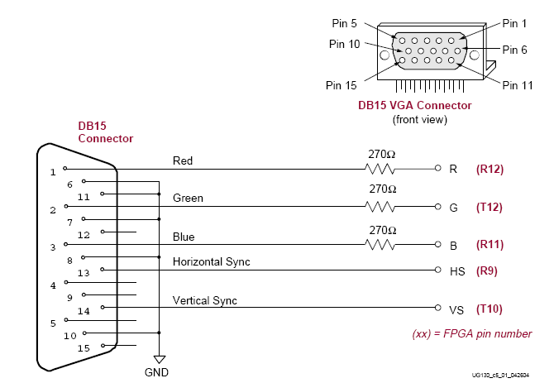

As seen in the above figure, the important pins needed and will be used are the Red, Blue and Green Pin to send the data for the color of the pixel. The other two pins that are important are the Horizontal Sync and the Vertical Sync that allow the designer to go around the Monitor pixels vertically and horizontally.

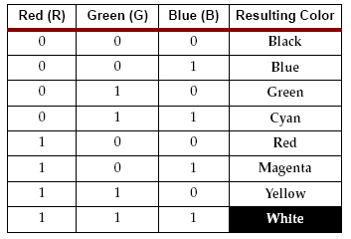

This table shows the data that should be sent through the Red, Blue and Green pins to send the value of the color. So it is an 8 color VGA port, that means 3 bits needed as shown.

Different Tasks within the Display Controller:

1. The first task is to get the map done and up on the monitor using the VGA port on the board.
2. The second task is to be able to show pacman on the monitor and move it around. Within the second task, implement the ghosts and have them go around the screen randomly.
3. be able to show the dots to be eaten by the pacman, and show that it is eaten also if pacman passes over it.
4. be able to update score on the monitor.

Schedule for completion of tasks:

Map : 11 / 15 – 11/20
pacman, Ghosts and Dots : 11/18 – 11/23
pacman Eating Dots : 11/22 – 11/25
pacman Score : 11/22 – 11/24
MAP and all other feature implemented with it: 11/25 – 12/02
Testing and Debugging: 12/02 – 12/07

Tools and resources to use:
Xilinx ISE, Modelsim, a monitor with VGA port, Spartan3 Dev board.

Data Storage(Krishnan’s part)

This part actually interfaces the input from the keyboard to the output of the screen.
It would contain various ROMs, RAMs and register files such that they are used to store all the data needed to run pacman. This data would be the respective co-ordinates of the elements such as pacman ,ghosts, energizer (optional), etc.

Basically, it contains the creation of:

- One or more ROM to store the map data.
- One RAM to store dot position data
- Register file to store the coordinate of the pacman and ghosts.
- some ROMs to store the element used for drawing everything on the screen.(will be done together with Nael)
This basically contains the mapping of data i.e. movement to be seen at the output (monitor) with changes made at the input (keyboard).

Tasks for this part include:

- Implement a method to encode the map with respect to co-ordinates along with the dot position data again in co-ordinates, so as to fit into memories on FPGA.
- Create ROM files that contain encoded map data.
- Create RAM files that contain dot position data.
- Create register file that contains coordinate data of moving elements.
- Create ROM files that contain graphic elements.

Schedule for completion of tasks:
Encoding methods, 11/12 – 11/15
Map ROM file, 11/16-11/20
Dot position file, 11/18-11/21
Coordinate register file 11/13-11/16
Graphic elements 11/16-11/24

Tools and resources to use:
Xilinx CORE generator, Xilinx ISE, Modelsim, Xilinx website, Spartan3 Dev board.

